**Amplitude metric calculation**

The amplitude metric will be calculated based on whether the signal point is in one of three areas:

1. Area 1 – signal point is within the tolerance tube
2. Area 2 – signal point is positive and outside the tolerance tube
3. Area 3 – signal point is negative and outside the tolerance tube

Note: the signal point amplitudes used to calculate the metric are those gotten after smoothing the original signal amplitude points with the Rectangular Smooth with Bark Scale. This is done to account for the logarithmic nature of the human perception of frequency.

Metric calculation for when the signal is in Area 1

If the signal is in Area 1, that means it is within the tolerance tube that has been specified by the BS EN 61672-1:2013 for Class 1 Sound Level Meters (SLMs). If a signal point is in that area, it will be given a metric score of 10. This has been done for the following reason.

The tolerance levels for SLMs specify the acceptable deviation of the measured loudness of the signal. These have been specified because the BS EN 61672-1:2013 standards[1] acknowledge that every SLM can’t measure exactly the same. This is due to the various components in SLMs (e.g. resistors, capacitors and microprocessors) having their own tolerances and variations. Even the test equipment will introduce variation. All of these variations add up to give each instrument it’s own variation from the ideal sound measurement. It is due to these variations that manufacturers of SLMs are allowed tolerances from the ideal. Depending on the Class type chosen for the SLM, the tolerances are different. For Class 1 SLMs, the allowed tolerances are tighter and have finite tolerance values that span over a wider frequency range than Class 2 SLMs.[2]

As the amplitude metric deals with the loudness of the signal, it was decided that these same tolerance values for Class 1 SLMs can be used to provide the acceptable deviations of the IR from the desired signal of 0 dB across different frequencies. Class 1 SLM tolerance values were chosen as they are considered to be more accurate, which would be highly desired in the context of a hearing aid.

In the metric, if the signal point falls anywhere within the frequency-dependent acceptable tolerance values specified by the BS EN 61672-1:2013 standards for Class 1 SLMs, then the signal point has a metric score of 10. This is because the signal point shouldn’t be penalized for not being exactly at 0dB if it is within the acceptable deviation, as the standards don’t penalize SLMs for not making an ideal measurement of the loudness of the sound so long as they meet the specifications for either Class 1 or Class 2.

Also because I always

Metric calculation for when the signal is in Areas 2 and 3

If the signal point is in Area 2, that means the signal is positive and outside the tolerance tube. In this area, the signal point should be penalized the further it gets from the upper tolerance level. At an upper limit amplitude of (20 dB + upper tolerance level), the metric should become closer to 0 and for amplitudes greater than this, it should be roughly equal to 0.

If the signal point is in Area 3, that means the signal is negative and outside the tolerance tube. In this area, the signal point should be penalized the further it gets from the lower tolerance level. At a lower limit amplitude of (-70 dB + lower tolerance level), the metric should become closer to 0 and for amplitudes smaller than this, it should be roughly equal to 0.

The upper and lower limits are based on the dynamic range of human hearing. The dynamic range of human hearing was derived from the Normal Equal-Loudness Level Contours defined by the BS ISO 226:2003 standards.[3]

The Equal-Loudness Level Contours define combinations of pure tones in terms of frequency and sound pressure level that are perceived as being equally loud. This is a fundamental property of the human auditory system and is important in the field of psychoacoustics.

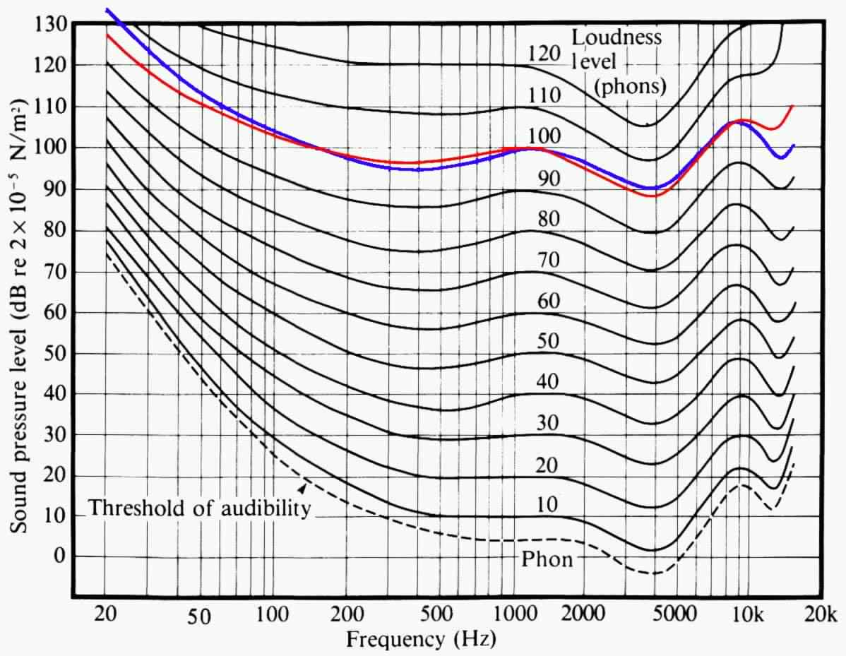

Figure 1: Equal-Loudness Level Contours

The curve at 120 phons (where phons is the value of the loudness at 1000 Hz on the curve) represents the human threshold of pain. Sounds at this threshold and beyond are painful to hear. The dotted line is the threshold of audibility, where a person is just able to hear a sound at the levels on the curve. Any sound below the threshold of audibility is inaudible. This means that at 1000 Hz, the dynamic range of human hearing (which is the difference between the loudest level and the softest level audible to the human ear) is 120 dB (120 dB – 0 dB).

In practice, this range can’t be reached for two reasons. Firstly, it isn’t advisable to listen to sounds at perceived loudness levels on the 120 phons curve as it is painful and can damage hearing.[4] Hence, for the purposes of the metric, we are instead working with the upper limit curve of 110 phons. Secondly, background noise masks the curves up till 20 phons, making them inaudible. Hence, the lower limit curve describing the softest sound we can hear is at 20 phons. Therefore, the dynamic range of human hearing at 1000Hz is 110 dB – 20 dB = 90 dB. To simplify the implementation of the metric, instead of having a variable dynamic range across frequencies, the dynamic range at 1000 Hz was used for all frequencies to calculate the metric.

Assuming that 90dB is the average decibel value corresponding to the loudspeaker, the upper and lower limits at and beyond which the metric should be 0 was calculated to be 20 dB and -70 dB respectively. However, as a tolerance tube has been defined around the ideal line at 0 dB for the impulse response of the transducer, it was decided to have the upper limit be equal to the sum of the upper tolerance level and 20 dB to account for the acceptable deviations. Likewise, the lower limit should be the sum of the lower tolerance values and -70 dB.

After the 2 regions between the tolerance tube and the upper and lower limits were identified, a curve had to be fit for the metric to show the decrease in the metric value as it gets farther away from the tolerance tube and closer to the limits.

To fit an appropriate curve, research was done into the human perception of loudness. It was found that the ear is highly non-linear, specifically logarithmic in terms of frequency and loudness. I tested this by doing basic linear vs log frequency tests and linear vs log loudness tests available on a website.[5] In both tests, I found that the log frequency scale and the log loudness scale sounded the most evenly spaced.

In the context of the metric, the farther away you get from the tolerance tube, the closer you get to 0 dB. Seeing as loudness perception in the ear is logarithmic, an exponential curve was chosen to calculate the cost on each signal point for not being within the tolerance tube. Also, seeing as the metric should go to 0 at and beyond the upper and lower limits, an exponential decay curve was chosen. This way, signal points beyond the upper and lower limits don’t have to be hard-coded to be 0 – the metric will take care of that through an asymptote.

Area 2 metric calculation

$Metric=10-10(1-e^{-0.12(x-uppertolerance)}$)

Where:

Cost = $10(1-e^{-0.12(x-uppertolerance)}$)

x = signal point amplitude

The cost vs signal amplitude is modelled as follows:

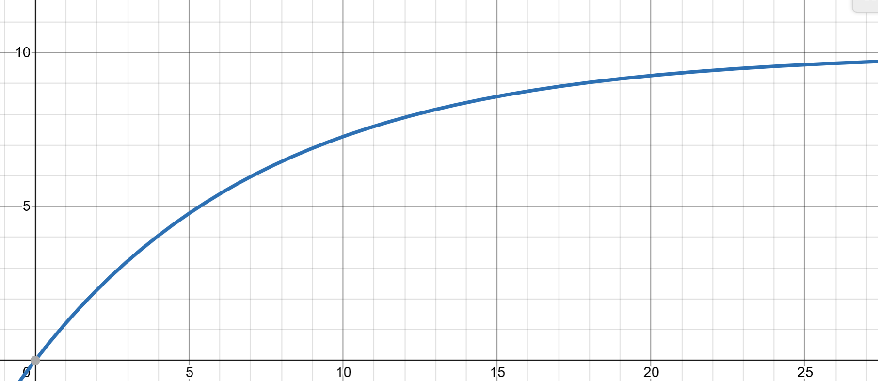

Figure 2 – Cost function for Area 2.

Note: horizontal axis is the signal amplitude and the vertical axis is the cost for that amplitude

As can be seen from the graph, the cost exponentially decays to 10 as it starts approaching 20 dB.

Area 3 metric calculation

$Metric=10-10(1-e^{-0.05(|x|-|lowertolerance|)}$)

Where:

Cost = $10(1-e^{-0.05(|x|-|lowertolerance|)}$)

x = signal point amplitude

The cost vs signal amplitude is modelled as follows:

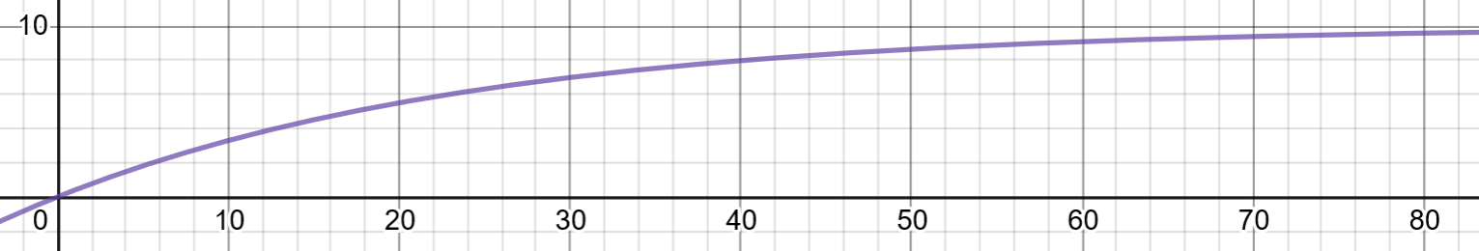

Figure 3: Cost function for Area 3

Note: horizontal axis is the signal amplitude and the vertical axis is the cost for that amplitude

As can be seen from the graph, the cost exponentially decays to 10 as it starts approaching 70 dB.

**Strengths and limitations of the Amplitude metric**

Strengths:

1. It accounts for the acceptable deviations of the signal amplitude from the ideal signal using the Class 1 SLM tolerances as specified by the BS EN 61672-1:2013 standards. This means the metric isn’t hypersensitive to small deviations from the ideal, making it be more practical in terms of how people work with uncertainties of measurements in the real world.
2. It accounts for the dynamic range of human hearing using the Equal-Loudness Level Contours specified by the BS ISO 226:2003 standards, making the metric account for the psychoacoustics of human hearing, hence suiting the context of this project.
3. By doing the Rectangular Smoothing using the Bark scale on the amplitude signal, the logarithmic nature of frequency perception by the human ear was represented in the metric.
4. By using an exponential decay curve to model the cost function for each signal point, the logarithmic nature of the human perception of loudness was accounted for in the metric.
5. Less values have to be hard-coded in this metric due to the use of asymptotes in the exponential decay curve for the cost function. Instead of having to hard code 0 at and beyond the upper and lower limits, the asymptotes for the cost function at 10 will automatically make the signal point be marked closer and closer to 0 the farther it gets.

Limitations:

1. The upper and lower limits of the metric are constants at 20 dB and -70 dB. However, in the Equal-Loudness Level Contours specified by the ISO standards, these upper and lower limits change across frequency and the dynamic range of human hearing also change across frequency (see Figure 1). This isn’t represented by the metric – the metric only uses the dynamic range at 1000 Hz from the curves (dynamic range of 90 dB) for all frequencies. This means that while the metric does account for the psychoacoustics of human hearing, it isn’t fully representative of it as the dynamic range varies across all frequencies.
2. The nature of the exponential decay curve poses some limitations in the calculation of cost. The change in cost is relatively high for signals that are at smaller distances from the tolerance tube than for signals that are at greater distances from the tolerance tube. This is another reason why signal points falling within the tolerance tube are given a score of 10 – it helps reduce the sensitivity of the metric to deviations from the ideal.
3. Could be interesting to add an extra measure of deviation within the tolerance tube in case we are measuring without a microphone. Here we are using 10 because there is a mic.
4. Human testing – couldn’t do it

**Conclusion**

I believe this metric is good enough for the purposes of this project, which is to quantitatively score the impulse response of the transducer before and after it has been filtered to see if it has become closer to the ideal line at 0 dB.

It accounts for the logarithmic nature of the human perception of frequency and loudness and the dynamic range of human hearing through the Equal-Loudness Curves, making it useful in the context of the hearing aid. It accounts for logarithmic perception of frequency through the smoothing with the Bark scale. It accounts for the logarithmic perception of loudness by using an exponential decay curve for the cost function, making it decay to 10 as the signal amplitude approaches the upper and lower limits of the dynamic range of human hearing.

It also accounts for the acceptable deviations from the ideal signal based on the tolerance levels detailed by Class 1 SLMs by the BS EN 61672-1:2013 standards, reducing the hypersensitivity of the metric to small deviations of the signal within the tolerance tube. This was done as SLM measurements that deviate from the ideal but still stay within the tolerance levels specified aren’t penalized, so it doesn’t make sense to penalize signal points in the metric when they are also within the tolerance tube.

While the metric has its limitations, I believe I have made the metric be as representative of the human ear as I possibly could based on existing literature. Every metric would have their own strengths and limitations and I believe I have maximized on the strengths and tried my best to minimize the limitations. While I could also conduct tests with human participants to gauge how they would score sounds of different quality and get a better model for my metric, that isn’t possible now due to COVID-19. Hence, I believe we should use this metric as the final one for this project.

1. Epl/29. Electroacoustics. Sound Level Meters. Specifications. 2013. Web.
2. “Differences Between a Class 1 & Class 2 Sound Level Meter.” *NoiseNews*, 6 Nov. 2018, www.cirrusresearch.co.uk/blog/2011/10/whats-the-difference-between-a-class-1-and-class-2-sound-level-meter/.
3. Eh/1. *Acoustics. Normal Equal-loudness-level Contours*. 2003. Web.
4. *Threshold_of_Pain*, www.sfu.ca/sonic-studio-webdav/handbook/Threshold_of_Pain.html.
5. Ir, and Stéphane Pigeon. “The Non-Linearities of the Human Ear.” *Free Online Audio Tests, Test Tones and Tone Generators*, www.audiocheck.net/soundtests_nonlinear.php.